Tessellations and Tiles
Task: In this exercise, you use the tools in Sketchbook Express on an iPad to create a tessellation pattern.
Approximate Time: 45 minutes
Files Accessed: Tessellation-Color.jpg

Note: You must have the Sketchbook Express app installed on an iPad to complete this exercise.

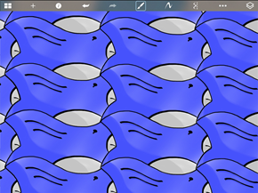
Completed Exercise
Create sketches to use as guides
- In Sketchbook Express, on the toolbar, click Brush.
- In the Brush Editor:
  - Set the radius to approx. 5.
  - Select the tool as shown.
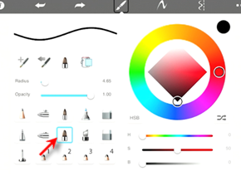
- On the toolbar, click Draw Style > Square.
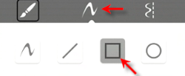
- In canvas, select the points to create a rectangle as shown.
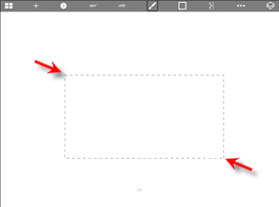
- On the toolbar, click Layer.
- In the Layer Editor, move the Opacity slider to the left as shown.
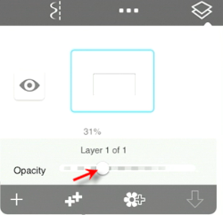
- In the Layer Editor, click New Layer.
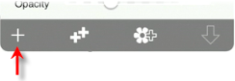
- On the toolbar, click Brush.
- In the Brush Editor:
  - Set the radius to approx. 1.
  - Select the Pen tool as shown.
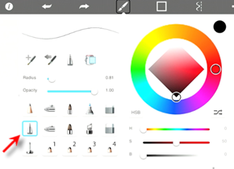
- On the toolbar, click Draw Style > Freehand.
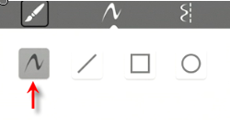
- In canvas, sketch the lines similar to the lines shown.
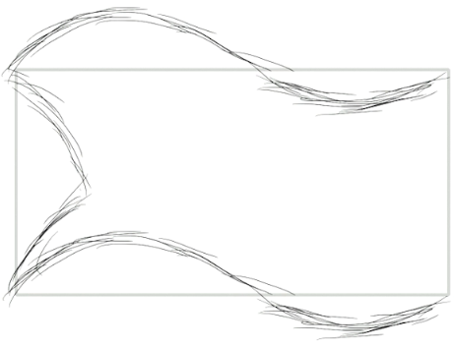
- On the toolbar, click Layer.
- In the Layer Editor:
  - Lower the Opacity.
  - Click Merge.
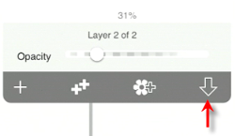
- When prompted, click Merge.
Trace the sketched elements
- In the Layer Editor, click New Layer.
- In Sketchbook Express, on the toolbar, click Brush.
- In the Brush Editor:
  - Set the radius to approx. 5.
  - Select the tool as shown.
- Trace the previously sketched elements as shown.
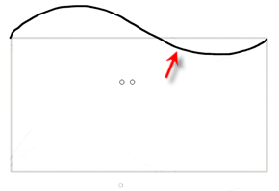
- On the toolbar, click Layer.
- In the Layer Editor, click Duplicate Layer.
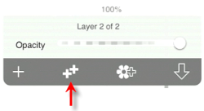
- On the toolbar, click More Tools > Transform.
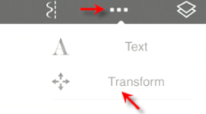
- On the toolbar, click Move Layer.
- Move the layer down as shown.
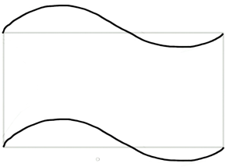
- On the toolbar, click Done.
- In the Layer Editor:
  - Click Merge to combine the top two layers.
  - Add a new layer.
- Draw the lines as shown.
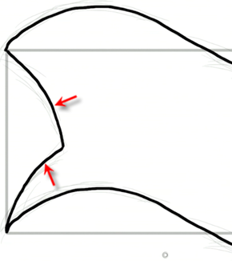
- In the Layer Editor:
  - Click Delete to remove Layer 3 (the layer that contains the sketched background elements and rectangle).
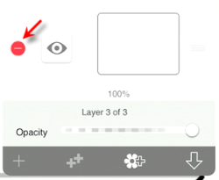
  - Click Delete to confirm.
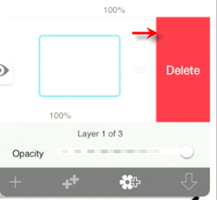
  - Duplicate Layer 1.
- Move layer over as shown.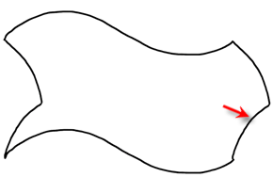
- Merge all the layers into one layer.
- On the toolbar, click Project.
- Click Save.

Add photo from the library
- In the Gallery, click the bird project. Click Edit.
- On the toolbar, click Layers.
- In the Layer Editor:
  - Create a new layer.
  - Click Import.
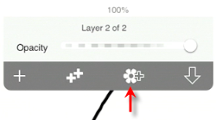
  - Click Photo Library.
  - Locate Tesselations-Colors.jpg. (You can select any image with the colors you want to use for the tessellation.
Note: Tesselations-Colors.jpg is provided with the datasets for this lesson. It must be saved to the Photo Library on your iPad to access it.
- On the toolbar, click More Tools > Transform.
- Scale, rotate, and move the image to an area of the screen where it is not covering the other elements.
- In the Layer Editor:
  - Create a new layer.
  - Drag the layer with the image on it to the bottom.
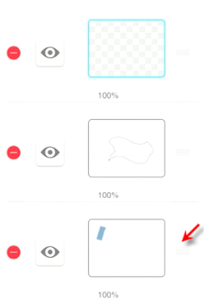
- In Sketchbook Express, on the toolbar, click Brush.
- In the Brush Editor:
  - Select the Brush tool as shown.
  - Set the Radius to approx. 10.
  - Set the Opacity to approx. 0.8.
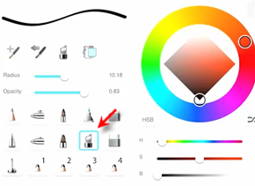
- Use the Brush tool to create additional detail.
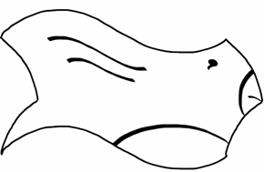
- In the Layer Editor:
  - Merge the top two layers.
  - Select the bottom layer to make it the active layer.
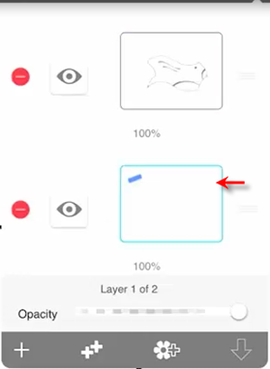
- In canvas, press and hold the Toggle UI.
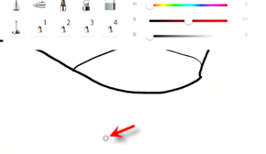
- Click the Eye Dropper tool.
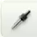
- With the eye dropper active, move the target inside the blue area of the color image.
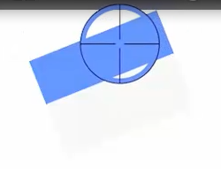
- On the toolbar, click Brush. In the Brush Editor:
  - Select the Air Brush tool as shown.
  - Set the Radius to 200.
  - Set the Opacity to approx. 0.09.
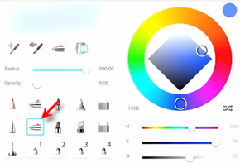
- Use the Air Brush to color blue over the entire bird drawing. Make multiple passes to get different shades.
Since the bottom layer is the active layer, the blue is displayed underneath the black lines
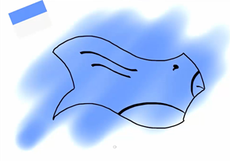
- In the Brush Editor.
  - Set the Radius to approx. 15.
  - Set the Opacity to approx. 0.3.
- Create shading beneath the wings and along the tail.
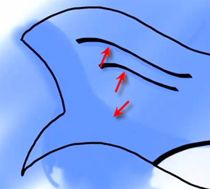
- In the Brush Editor, select the Eraser tool and use it to erase the blue on the beak and stomach of the bird.
- Repeat the steps to:
  - Color the beak and stomach of the bird to match the grey color in from the color image. Change the Opacity setting to create the shading.
  - Clean up the color all the way around the image.
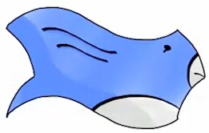
- Merge all the layers.
- On the toolbar, click More Tools > Transform.
- Use the Scale tool to make the bird smaller on the canvas.
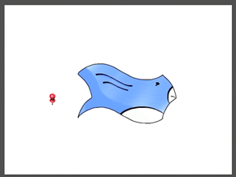
- To save the project:
  - On the toolbar, click Project.
  - Click Save.
  - In the Gallery, click the bird project. Click Edit.
- Duplicate the layer and move the layer above the other so they are aligned as shown.
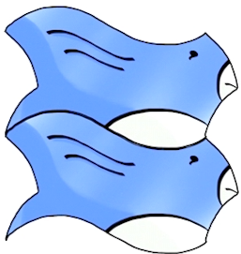
- Merge the layers.
- Move the layer to the upper left corner of the canvas.
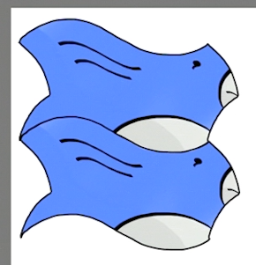
- Duplicate the layer and move the layer so it aligns as shown.
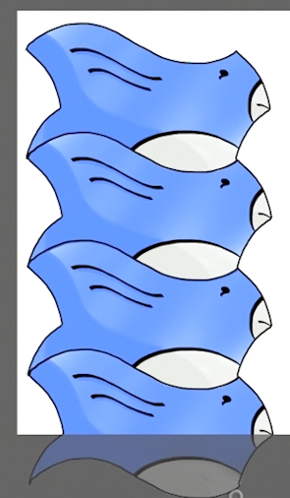
- Duplicate and move layers to complete the tessellation as shown.
- Save the file as necessary.
- End of exercise.

